July 9, 1915
Fasting During the Month of Ramadhan: An Excellent Means of Spiritual Progress
I bear witness that none deserves to be served besides Allah and I bear witness that Muhammad is the servant and messenger of Allah. —
After this, I seek the protection of Allah from the accursed devil.
In the name of Allah, the Beneficent, the Merciful.
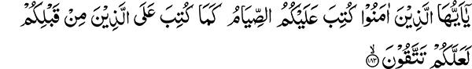
“O you who believe, fasting is prescribed for you, as it was prescribed for those before you, so that you may guard against evil.” (2:183)
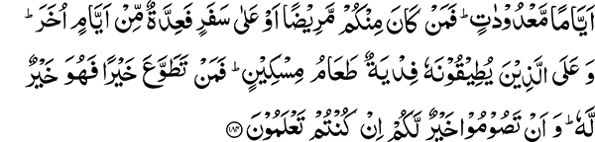
“For a certain number of days. But whoever among you is sick or on a journey, (he shall fast) a (like) number of other days. And those who find it extremely hard may effect redemption by feeding a poor man. So whoever does good spontaneously, it is better for him; and that you fast is better for you if you know.” (2:184)
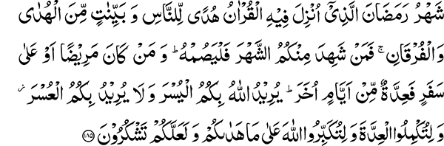
“The month of Ramadan is that in which the Quran was revealed, a guidance to men and clear proofs of the guidance and the Criterion. So whoever of you is present in the month, he shall fast therein, and whoever is sick or on a journey, (he shall fast) a (like) number of other days. Allah desires ease for you, and He desires not hardship for you, and (He desires) that you should complete the number and that you should exalt the greatness of Allah for having guided you and that you may give thanks.” (2:185)
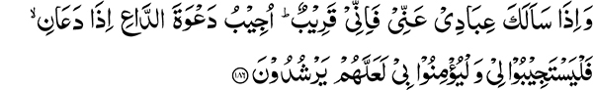
“And when My servants ask thee concerning Me, surely I am nigh. I answer the prayer of the suppliant when he calls on Me, so they should hear My call and believe in Me that they may walk in the right way.” (2:186)
Spiritual Sustenance for the Month of Ramadhan
The month of Ramadhan is about to begin; therefore, I feel it is essential to provide some information about it. These matters have been repeatedly related to you, but just as man needs to eat and drink frequently for his physical well-being, the same is true regarding spiritual sustenance. It needs to be offered frequently. Just as physical requirements are an essential part of our being, it is also necessary that we receive periodic reminders of matters that are spiritually beneficial to us. By nature, man tends to forget previous reminders and with the passage of time their effect wears off. Even the companions of the Holy Prophet used to say: “O Messenger of Allah when we are in your presence the state of our mind is different than when we depart from your company.” The companions of the Holy Prophet, may Allah be pleased with them, realized this. Every person is in need of someone to counsel him or her; the human mind is in want of repeated stimulation.
Sighting of the Moon
The month of Ramadhan has either twenty-nine or thirty days, although nowadays people do not allow thirty days to be completed. Only Allah knows if the month is actually of twenty-nine days but people take false oaths of having witnessed the new moon. Nevertheless, this has been my experience. In any case, someone who has completed twenty-nine days of fasting should not find it hard to fast for another day.
Timings for Beginning and Ending the Fast
Early in the morning, there is a period called the tint or break of dawn. This period extends from approximately one hour and twenty-two minutes to one hour thirty minutes before sunrise. The fast is to be kept beginning at this time, until sunset. Some people consume their morning meal very early. One should take advantage of the permission given by the Holy Quran and also follow the Holy Prophet who would wait until this time to consume his meal. Currently, one could get up at approximately two o’clock at night, pray for half an hour, spend one and a half hours to take care of other needs and consume his meal around four a.m. And quit eating as soon as the morning is fully established. Some people quit eating when they hear the call for the morning prayer. There is no harm in confirming this, for sometimes if the prayer call is made earlier, it is better to wait until the break of dawn.
The fast ends at sunset. The Holy Prophet used to have his meal prepared beforehand to break the fast at sunset. In our country, people sometimes wait until it is dark before they break their fast. The fast should however be broken at sunset; the redness of the evening sky has no relation to sunset.
Prohibitions During Fasting
It is prohibited to eat and drink during the time of fasting and also conjugal relationship is restricted during this time. There are other minor matters that are of lesser importance.
What is the Purpose of Fasting?
There is no commandment in Islam that does not have a purpose and an underlying goal. It is certainly not a religion that goes against this philosophy. If a command is given and the purpose is not defined, one can falter and fail to fulfill the true intent of the injunction. If the purpose, however, is well defined alongside the commandment and it is not fulfilled, then doing the task or not doing it is the same. Allah the Most High states:
“O you who believe, fasting is prescribed for you, as it was prescribed for those before you, so that you may guard against evil.” (2:183)
This tells us that the real intent and underlying purpose of fasting is to guard against evil. Therefore, if a person stays hungry and thirsty and does not stay away from doing evil, he has failed to accomplish the command. For example, if a person is delegated to collect land revenue and he collects it but fails to deposit it in the state treasury, he has failed to do his duty and is likely to be apprehended by the authorities.
Wisdom Behind Every Injunction
All the commandments of Islam, with an apparent physical prohibition, also have an underlying spiritual truth. In connection with the sacrificial animals, the Holy Quran states: “Not their flesh, nor their blood, reaches Allah, but to Him is acceptable observance of duty on your part.” The purpose of all forms of sacrifice is to guide you toward righteousness. In Ramadhan you are commanded to give up or sacrifice what is otherwise lawful for a limited period of time. Consider this situation for a moment. Out of your legal and wholesome earnings, you have prepared a glass of cold water or a sweetened drink and you are extremely thirsty. At the same time, you are hungry. There is food on the table and you are in a room by yourself, where there is no one to see you. Why would you avoid eating and drinking under these circumstances? It is because you are aware of what God has commanded. Guarding against evil and following the path of righteousness is the purpose of fasting. You can keep your duty and acquire these qualities by fasting. These thirty days require an effort and striving on your part. Man remains unaware of God’s presence because of his many worldly pursuits. For a month, Allah the Most High wants to develop and strengthen your spiritual faculties and by subjecting you to some degree of hunger, wants you to humbly turn toward Him.
Special Acceptance of Prayer during Ramadhan
The Holy Quran states:
“And when My servants ask thee concerning Me, surely I am nigh. I answer the prayer of the suppliant when he calls on Me, so they should hear My call and believe in Me that they may walk in the right way” (2:186)
Having this verse next to other verses about Ramadhan indicates that it has a special connection with the subject of fasting. If someone desires acceptance of his prayers, he should take advantage of this privilege. How many people are dependent upon others praying for them? God has shown you the way, “so let him who please believe and let him who please disbelieve” (18:29).
Those who fast but do not understand the real purpose of fasting, remain in a vulnerable state.
Confinement in the Mosque During the Last Ten Days of Ramadhan
“…And touch them not while you keep to the mosques…” (2:187)
In the last ten days of Ramadhan, if Allah the Most High gives someone the ability to do so, one may give up his worldly pursuits and confine himself to the mosque. I wish someone would take up this practice in our mosque this year. Striving is to be done within the limitations of one’s physical faculties. The faculties of a person who is ill become weak; that is why the supplications of one suffering from an illness are readily accepted. This is the reason why I‘tikaf is prescribed after twenty days of fasting for, as a result fasting, the physical faculties (basic desires) are weakened and it is therefore an opportune time for prayer and supplication.
The Affluent Need to Strive Harder
Jesus said that it is easier for a camel or a cow to pass through the eye of a needle than it is for the rich to enter the kingdom of God. The Hadith also says that the poor will enter Paradise five hundred years ahead of the affluent. The love of wealth prevents the rich from coming near goodness.
Charitable Spending Should be Greatly Increased During Ramadhan
Fasting during the month of Ramadhan has a special relation with the worship of Allah the Most High. For those who cannot fast, it is said: “And those who find it extremely hard may effect redemption by feeding a poor man.” About the Holy Prophet, it is said that he was the most charitable of all people, but during the month of Ramadhan he was even more charitable. Do give in charity during the month of fasting. The most in need of your giving at this time is Islam; therefore also give for the cause of your religion.
Standing up for Prayer during Ramadhan
Listen to the Holy Quran in the early part of the night and pray also before the break of dawn. This is a time of great receptiveness of supplications and worship and the process is much enhanced during the month of fasting. So prepare yourself and control your tongues. Seek forgiveness and protection from sin, exalt Muhammad, and the true followers of Muhammad (As-sala-n-Nabiyy), and abstain from useless talk.

This verse refers to the voluntary practice of confining oneself to the mosque for the last ten days and nights of Ramadhan. The practice is known as I‘tikaf.

